Translating and rotating data

Translations and rotations move the origin and coordinate system from the default position to a different orientation. The default 2-D coordinate system locates the origin at the bottom left corner of the image, with the X-axis along the bottom of the image and the Y-axis up the vertical edge of the image. Thus, the camera position specifies the default origin and direction of the axes. The default 3-D coordinate reference system is defined by the position and orientation of the control object. The position of the cameras has no relation.

Translating and rotating a constant amount

A constant translation moves the origin along the specified axis a known distance.

Example – constant translation

A subject lifts a box from a pallet four inches off the ground and places it on a conveyor belt. In this case, move the origin to the 4-inch height of the pallet. Enter values as follows:

X-axis translation Constant: 0
Y-axis translation Constant: 0
Z-axis translation Constant: -4
X-axis rotation Constant: 0
Y-axis rotation Constant: 0
Z-axis rotation Constant: 0
Note Units of the value entered must match the units used in determining the object space. In this case, a negative value is entered, because the net change is negative.

A constant rotation rotates a plane about an axis. To rotate the XY-plane about the Z-axis, enter a non-zero value in the Z-axis field. You may enter a constant 180 degrees in the X column to flip a trial vertically, or enter a constant 180 degrees in the Y column to flip the trial horizontally.

Example – constant rotation

If a study requires a subject be videotaped on a treadmill set at a 30 degree angle, it may be necessary to rotate the coordinate system 30 degrees. Therefore, when displayed in a report, the subject appears to be walking on flat ground. In this case, click on constant in the X and Y rotation boxes and enter 30 in the units box in both the X and Y columns. Using the right-hand rule, hold your right hand so that your thumb is pointing along the positive Z-axis, then the XY-plane will rotate in the direction your fingers are pointing. Enter values as follows:

X-axis translation Constant: 0
Y-axis translation Constant: 0
Z-axis translation Constant: 30
X-axis rotation Constant: 0
Y-axis rotation Constant: 0
Z-axis rotation Constant: 0
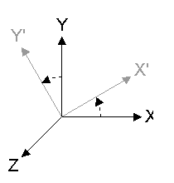

Defining a picture where translation and rotation occurs

A picture rotation causes the indicated axis to be rotated through the location of the specified point at the specified picture number.

Example

In a long jump study you may want the X-axis to follow the line of flight. Therefore, translate the origin to the foot position at take-off in both the X, Y, and Z columns, and rotate the X-axis to intersect the same point at landing. If take-off occurs at picture 20 and landing occurs at picture 65, enter values as follows:

X-axis translation Picture: 20, left foot
Y-axis translation Picture: 20, left foot
Z-axis translation Picture: 20, left foot
X-axis rotation Picture: 65, left foot
Y-axis rotation Constant: 0
Z-axis rotation Constant: 0
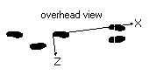

Defining an event where translation and rotation occurs

An event rotation causes the indicated axis to be rotated through the location of the specified point at the first occurrence of the specified event.

Example

In a gait study, you may want the X-axis to be along the line of travel. Then a change in X values is antero-posterior and a change in Z values is medial-lateral. The direction of travel can be defined as the line between consecutive heel strikes, on the same side of the body. Enter values as follows:

X-axis translation Event: first left heel strike
Y-axis translation Event: first left heel strike
Z-axis translation Event: first left heel strike
X-axis rotation Event: last left heel strike
Y-axis rotation Constant: 0
Z-axis rotation Constant: 0
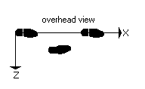

Repeating a translation and rotation throughout the trial

A repeated translation moves the origin to the location of the specified point, picture by picture. Therefore, all analyzed motion is relative to the specified point. For example, if the origin is moved to the center of mass in both X and Y, all motion is relative to the center of mass.
It is also acceptable to rotate about two axes. This would be necessary to assure that a plane is aligned correctly, instead of just an axis.

Example

Measure a swimmer’s stroke pattern. Using the repeat translation and rotation option, it is simple to determine motion of the arms with respect to the shoulders. First translate the origin to the left shoulder for the X-, Y-, and Z-axes. Then rotate the Z-axis so that it intersects the right shoulder. Enter values as follows:

X-axis translation Repeated: left shoulder
Y-axis translation Repeated: left shoulder
Z-axis translation Repeated: left shoulder
X-axis rotation Constant: 0
Y-axis rotation Constant: 0
Z-axis rotation Repeated: right shoulder

Calibrating for a 3-D trial
(for info see http://kwon3d.com/theory/dlt/dlt.html)

There are many methods to obtain 3-D coordinate data from multiple 2-D views. Motus uses the Direct Linear Transformation (DLT) method. Use the Calibrate tab to digitize a control object of known coordinates. Then, you can calculate the image space and determine any movement throughout the image space. The DLT method establishes a direct linear relationship between the digitized 2-D coordinates from multiple cameras and the 3-D space coordinates by using intersections of lines, or vectors, from each camera view to determine the point location in space. Best results occur when any two cameras are between 60 degrees and 120 degrees apart. The DLT method will not work if two cameras have their optical axes at exactly 180 degrees.

Global transformation frame

This apparatus defines an additional three-point control object used to translate and rotate the origin to a position along the plane of movement. This is used primarily with gait analysis to translate the origin to the front right corner of a force plate. Rotation is also changed to relocate X as anterior-posterior, Y as medial-lateral, and Z as vertical.

Skipping points

Sometimes not all control points are seen in all views. However, you can still calculate the DLT parameters based on the points that are digitized. For example, use a 25 point calibration frame, but digitize only 19 points. Since each camera has its own set of DLT parameters independent from one another, each camera does not need to see exactly the same points to compute these parameters. Just skip points that are not visible. After computing the DLT parameters for all cameras, the software computes the 3D coordinates of the control points but uses only the points digitized from all camera views.

Print preview

Click Show DLT parameters to preview the DLT parameter output file. Then click Print to print the page to the printer or to print to a file.
Note The output file leaves values blank for the points excluded.

1 On the File menu, select New Trial.

2 On the Setup tab, click Select Cameras and add at least two cameras.

3 On the Calibrate tab, click the Control object icon to display the Control Objects dialog box.

4 Select the DLT parameters you want to use in the DLT calculations.

5 Click Capture Video Image to display the Digital Video Recorder.

6 Record a video of the control object. (Whatever duration you’ve entered is automatically cropped to two frames.)

7 Close the Digital Video Recorder.

8 On the Calibrate tab, click Digitize control points.

What do you want to do?

Translate and Rotate the coordinate system
Learn about the DLT method
Create a control object
Use the DVR to capture a video clip
Digitize the control object
Determine the object space calibration error
Get more information about the control object

Direct Linear Transformation (DLT)

By supplying a set of control points with known X-, Y-, and Z-coordinates from the control object, the Direct Linear Transformation (DLT) method determines the orientation of the image space of the video chips in the camera, with respect to the object reference frame. For a two camera, 3-D system, six non-coplanar points on the control object are required. Using the least-squares method to determine the best fit, camera parameters are determined. These camera parameters are constant as long as the position of the cameras, the lens focus, and focal length remain unchanged.

More control points will improve accuracy, but the point of diminishing returns is near 20 points. If using poor lenses or a small focal length, a lens distortion correction may be necessary. The 12th parameter is used for first order symmetrical lens distortion, the 13th and 14th parameters are used for the fifth and seventh order terms of symmetrical lens distortion, and the 15th and 16th parameters are used for asymmetrical lens distortion.

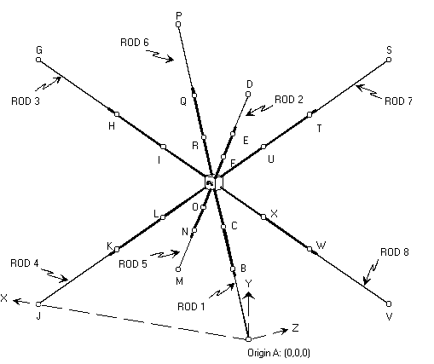

DLT Computations

Using the optical lens theory, the following sets of equations can be defined, where:

- camera number m=1, ..., 6

- control point number n=1, ..., n

- Umn=horizontal camera orientation

- Vmn=vertical camera orientation

- A through L=camera parameters

Image Space

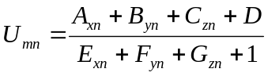
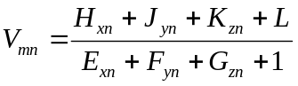
Object Space

x = f(Umn,Vmn)
y = g(Umn,Vmn)
z = h(Umn,Vmn)
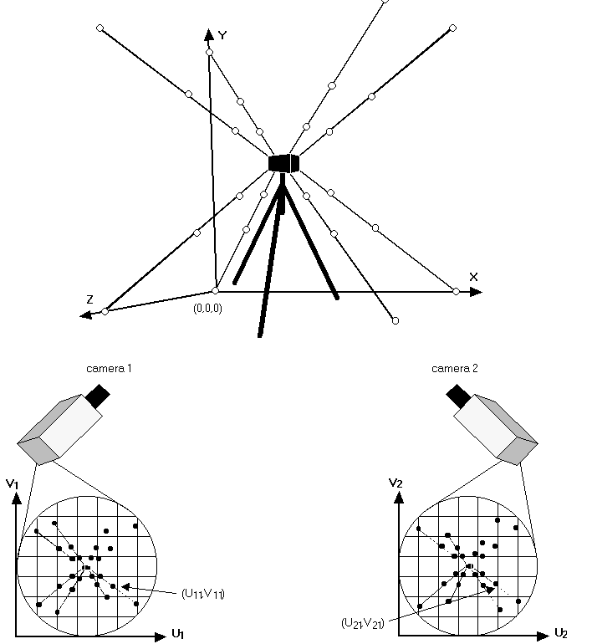

By supplying a set of known control object X-, Y-, and Z-coordinates, and digitizing the U and V coordinates in each camera view, the following set of equations may be written for each camera.

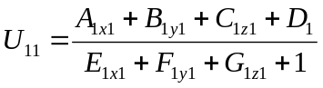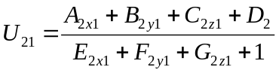
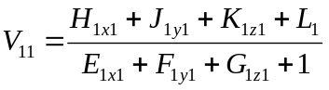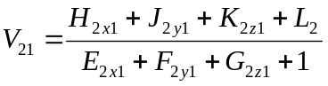
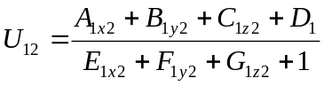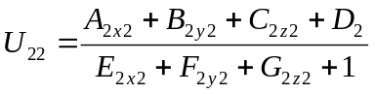
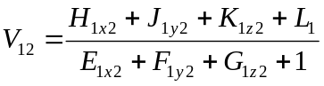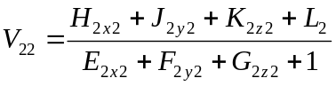
… …
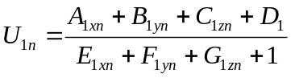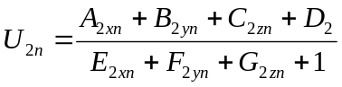
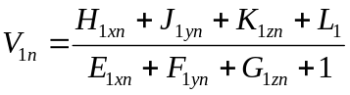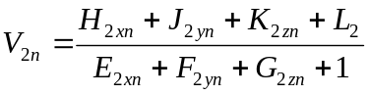

Kwon:
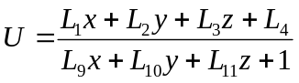
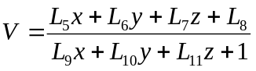

Supplying at least six non-coplanar points (x,y,z coordinates) over-determines the system of equations and the unknowns A through L (camera parameters) may be calculated by the least squares approximation. In matrix form for each camera, the above systems can be written as the following:
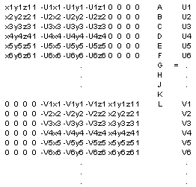

The x, y, and z coordinate of a point can be determined by using the following matrix equation:
(L1 *g= L2)

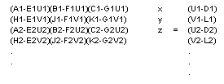
Supplying the A through L for each camera and the digitized U1, V1, U2, and V2 from each camera, x, y, and z can be found, calibrating the object space.

DLT references

- Abdel-Aziz, Y.I. and Karara, H.M. Direct linear transformation from comparator coordinates into object space coordinates in close-range photogrammetry. ASP Symposium on Close-Range Photogrammetry. American Society of Photogrammetry, Falls Church. pp. 1-18, 1971.

- Miller, N.R., Shapiro, R., and McLaughlin, T.M. A technique for obtaining spatial kinematic parameters of segments of biomechanical systems from cinematographic data. Journal of Biomechanics. 13:535-47, 1980. UCB Engin QP303.A1 J6

- Shapiro, R. Direct linear transformation method for three-dimensional cinematography. The Research Quarterly. 49:197-205, 1978.

- Gazzani, D., 1993. Comparative assessment of two algorithms for calibrating stereophotogrammetric systems. Journal of Biomechanics 26, 1449-1454.

- Hatze, F., 1988. High-precision three-dimensional photogrammetric calibration and object space reconstruction using a modified DLT-approach. Journal of Biomechanics 21, 533-538.

Determining the object space calibration error

The Motus System does not determine if the standard errors calculated are acceptable for the particular study. In some cases a one millimeter error is acceptable, for others it is not. It is the sole responsibility of the user to assure that the residual error is at a level which will provide accurate data. If large standard errors are obtained, check that points were digitized in the correct order and control point coordinates were entered in the Control Object Setup correctly.

When used correctly, Motus produces X-, Y-, and Z-coordinates within an accuracy of 0.5 percent. For example, the Peak 3-D Calibration Frame control object is approximately 2.2 meters in the X and Y direction, and 1.6 meters in the Z-direction. That gives a diagonal distance of approximately 3.5 meters. 0.5 percent of 3.5 meters is 0.0175 meters. Therefore, as long as the X, Y, and Z errors are less than 17.5 millimeters, the calibration would be within the accuracy of 0.5 percent.

Mean Square Error

Displays the net error for all points for X, Y, Z, and position (the resultant distance between the measured and computed points). This number provides a representative measure of the intrinsic error of that particular camera configuration and arrangement.

Object Space Percent Error

Displays the average mean square error as a percentage of X, Y, Z, and position. This is the overall error of the calibration.

Using the Peak 3-D Calibration Frame control object

The Peak 3-D Calibration Frame control object provides unsurpassed flexibility and precision. This frame was designed to optimize size, aspect ratio, and portability, as well as the number of control points for Direct Linear Transformation (DLT) calibration.
The control object coordinates are computed using precision surveying equipment and trigonometry. Peak Performance Technologies, Inc. surveys each frame and you receive a table of the coordinates for your control object.

Setup recommendations

To make assembling and leveling the calibration frame relatively easy, keep the tripod legs un-extended, but spread them to the medium position. This gives a sturdy base and keeps the legs the same length. Raise the head by sliding the center post up to allow enough room to fasten the lower rods to the core. Once assembled, adjust the frame height by sliding the center post. This is much easier than manipulating the legs. Rotate the head about the vertical axis to the desired final orientation. Level the frame by adjusting the tripod head joints while viewing the spirit levels imbedded in the head.

There may be slight deviations between the design and the product brought about by the manufacturing process. Leveling the calibration frame does not necessarily ensure that the Y-axis is perfectly vertical (the coordinate axes are mutually perpendicular). This can be corrected with translations and rotations.

Storing your frame

This case is designed primarily for storage and casual transportation. Please take precautionary measures if you must ship it. Remember, this is a delicate, precision instrument.

